Sailing Secretary’s Report – September 2018

- We had a very successful RYA inspection of our Training Centre facilities and resources. Thank you to Katie Hooper for a great deal of work in getting us ready for this, and also for carrying out the role of Chief Instructor in addition to her Principal responsibilities.

- Lucy and Kate McGregor from Poole YC and Annie Lush from Parkstone YC took first place in the Women’s Matching Racing World Championship in Ekaterinburg in Russia.

- Poole YC boats took part in the Osprey Nationals in Weymouth and the GP14 Nationals in Mounts Bay; congratulations to Mel Brown for being one of 5 women helms in a fleet of 133 boats. Congratulations also to Joe Cross for his first place in the Sonata Nationals in Medway, and Matt Burge taking first place in the Fireball World Championship. 29 YW Dayboats took part in the Nationals in Poole Harbour and Poole YC played host to 180 Optimists in early September; we have been thanked for the warmth of our welcome to them, and the high standard of organization and race management assistance.

- Poole YC youth sailors have been travelling too. Some not far to Parkstone Youth Week, where Ocean ( ) took first place in the Bronze fleet. Angus Kemp and James Foster have been competing in Laser 4.7 competitions around UK and Europe, with James taking first British boy in the European Championships, under 17.

- The dinghy yard review is complete, and spaces created for dinghies as a result. More active scrutiny of which boats are in the yard, and how often they are being used, will continue. This because the pressure on boat storage space is not expected to reduce given the continued growth in active sailing members.

- Work is underway with the Youth Section to think through how we move to a broader Training Committee remit, without losing the commitment to the very popular, and resource-intensive, Wednesday evening youth training. An important first step will be to bring the strands of Training costs and income, into one ‘balance sheet’.

- Katie will be organizing Senior Instructor and Dinghy Instructor training over the winter period, which together with additional Jaffa capacity, and the planned introduction of 6 Fusion dinghies, will enable us to expand the training offered to adults and teenage sailors.

- General Committee has agreed to the extension of our sailing training to a small number of courses offered to non-members, at times when the club sailing facilities are not in use. Developing this aspect of club life, and also approaching class associations to present Poole YC as a potential venue for external events, sees the strategy of having the Sailing Pro role coming to fruition.

Tracey Lee, Sailing Secretary
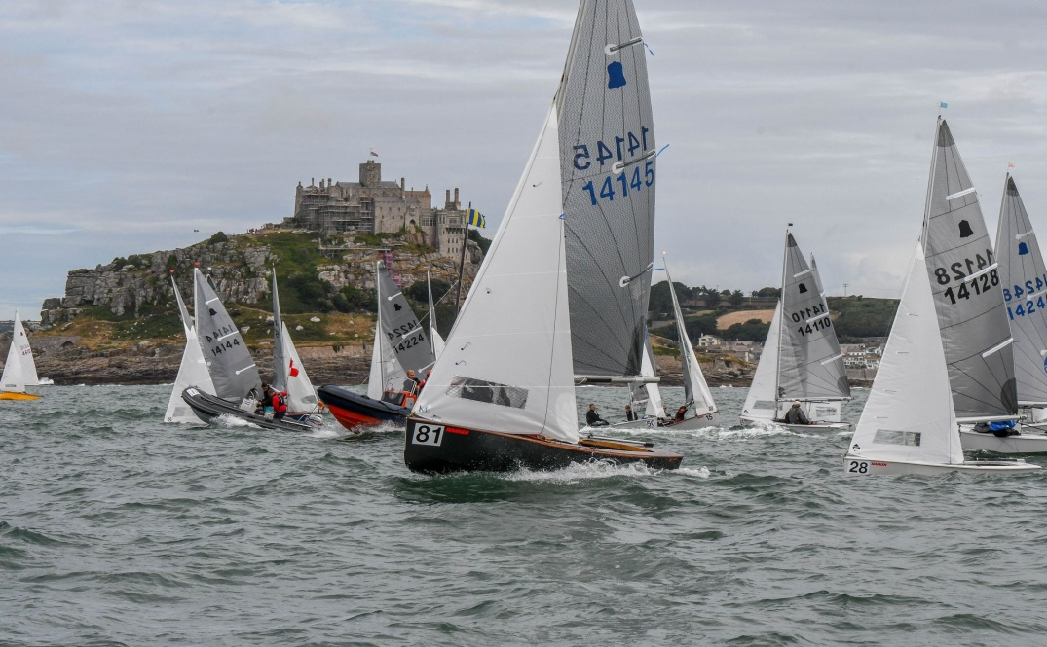
GP14s at Mounts Bay, Cornwall
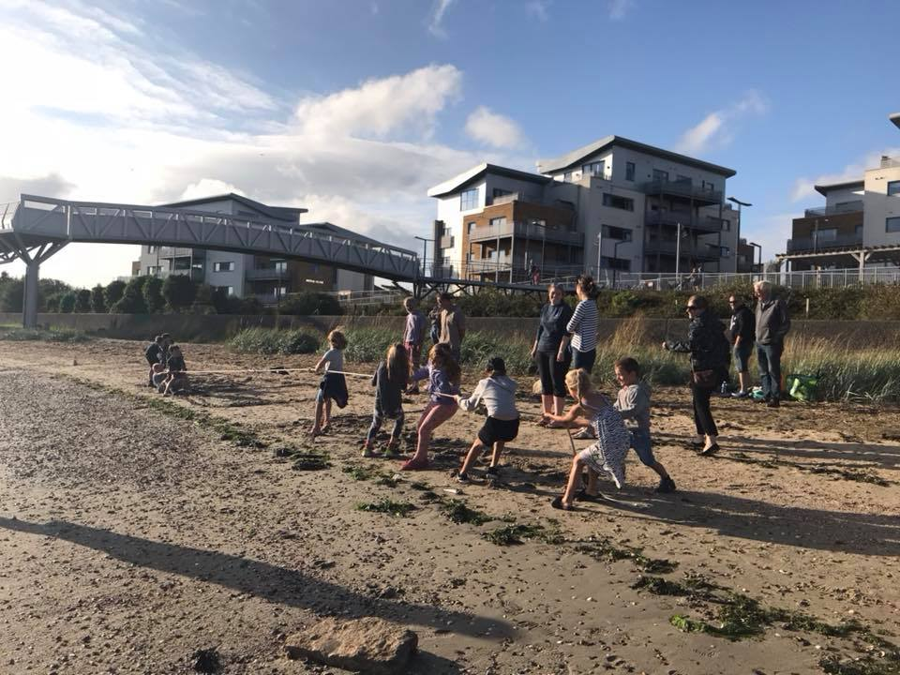 Opi One Tug of War
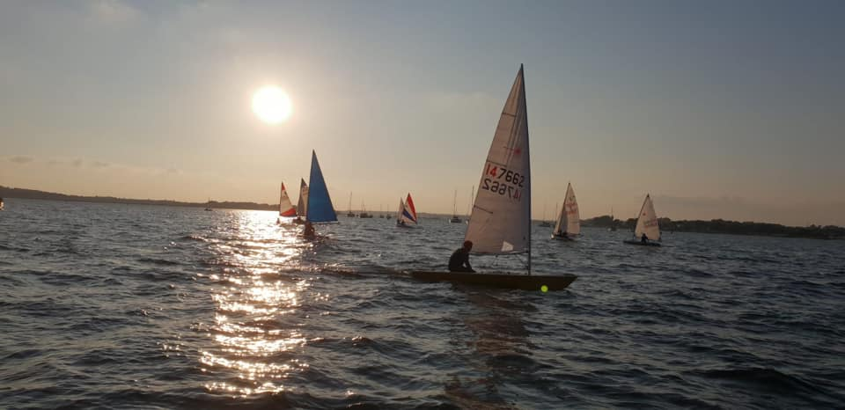 Friendly Fridays

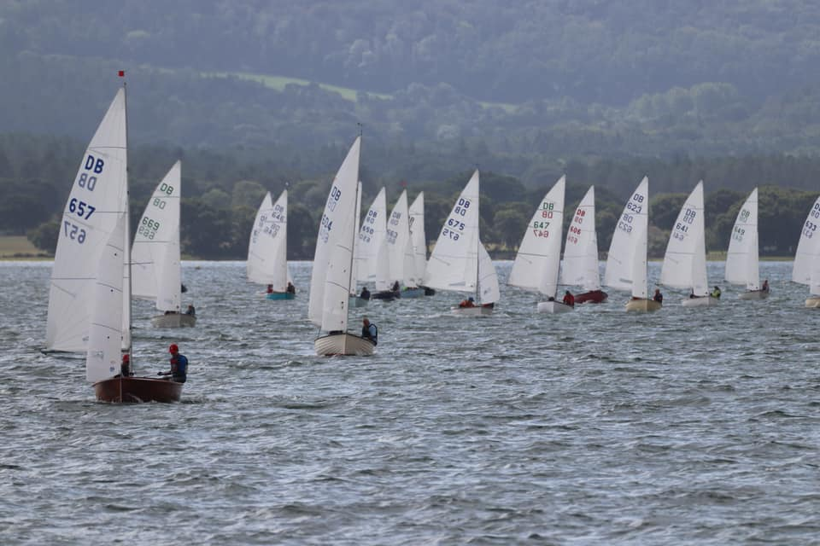
Yachting World Dayboat Nationals in Poole Harbour

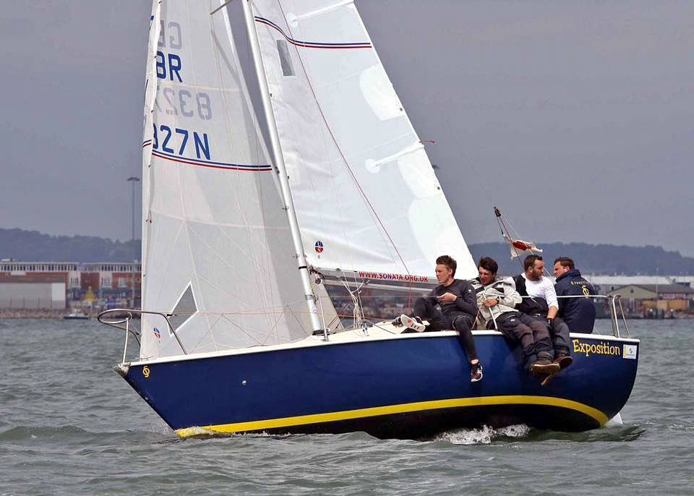
Joe Cross and team in action

